Lab #
Title:

Responsible Lab TA:

Group #:
Team members:
1.
2.
3.

Lab date (s):
Report due date:

Team Contribution Statement
Enter each member’s initials in every column they contributed to, and give each member an overall percentage. The percentages must total 100%.

Team member | Experimental work and data collection | Analysis | MATLAB/Simulink code | Interpretation and validation | Report writing and editing | Overall contribution
Member 1: |  |  |  |  |  | _____%
Member 2: |  |  |  |  |  | _____%
Member 3: |  |  |  |  |  | _____%
Total |  |  |  |  |  | 100%

Acknowledgement: By submitting this report, all team members confirm that the information above accurately represents their contributions and that all team members have reviewed and approved the final report and associated files.

A common grade will normally be assigned to all team members. The instructor may request additional information when the contribution statement or other evidence indicates substantially unequal participation.

Your lab report should address all the questions in the handouts and demonstrate a solid understanding of the lab concepts. A formal report format is not required. There’s no need to include an equipment list or step-by-step procedure. Instead, focus on explaining your observations and the depth of your understanding.
Discussion answers are typically three to six sentences, each supported by a figure or a number from your own data. Questions marked for your own understanding need no written answer.

Formatting:

- Reports must be typed; handwritten submissions will not be accepted.
- Some questions require you to add your MATLAB code; For these, you need to use MATLAB Live Editor.
With every report, you can only submit one mlx file and its exported pdf file.
Do not hide the code, and make sure the code and output are presented.
- For guidance, see the MathWorks pages on creating live scripts (mathworks.com/help/matlab/matlab_prog/create-live-scripts.html) and on publishing MATLAB code (mathworks.com/help/matlab/matlab_prog/publishing-matlab-code.html).
- Number pages.
- Use 12-point Calibri or Times New Roman font.
- Maintain 25 mm (1 inch) page margins, as set in this template.
- Align text to the left.

Tables and Figures:

- Tables and figures require appropriate captions and numbers.
- Label tables numerically (e.g., "Table 1") and figures as (e.g., "Figure 1").
- Place table captions above and figure captions below.
- Ensure figures have clear labels on both axes with units.
- Utilize MATLAB xlabel, ylabel, and legend commands.
- Font size for labels and legends should match the report text for readability.
- Clearly define all labels and captions, explaining abbreviations in the text.
- Include units for all reported numbers in text, figures, captions, and labels.
- When displaying two lines on a single plot with different scales, use two separate axes in the same figure. For example, do not show both 0-10 and 90-100 variations in a single plot with a range of 0-100.
- Do not present plots with a black background. If the figure is generated by MATLAB SIMULINK, you can click on File, and Copy to Clipboard to import a white figure to your report.
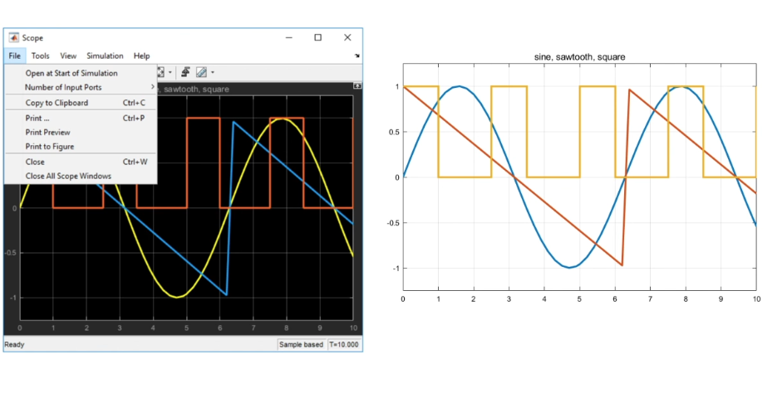
- Example of an appropriate figure:
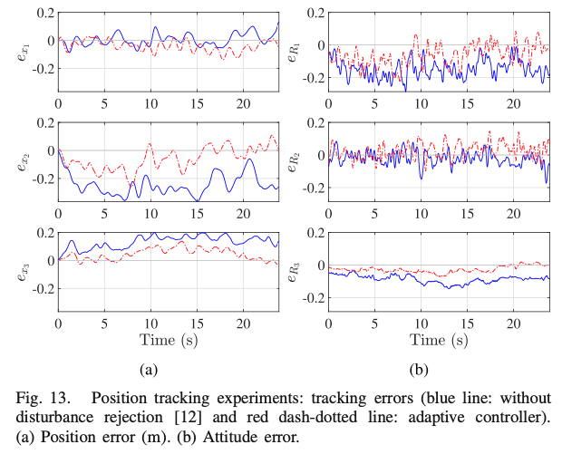
- Optional: To learn more, read the paper by Rougier et al. titled Ten Simple Rules for Better Figures [1].
- Optional: “Stop using the red/green colour combination” to make figures more accessible [2].

Equations:

- Number equations for reference, e.g.
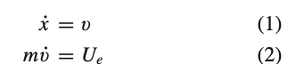

Submission:

- Submit the report as a single PDF in the designated Dropbox folder on D2L, unless the lab manual asks for additional PDF files — Lab 2 requires three PDFs and Lab 3 requires two.
- Include screenshots of the code and Simulink with adequate descriptions.
Submit programming codes as additional files, without compression (no zip files). You can upload one mlx file and multiple Simulink files if required.
- Name every file as Lab#_Group##_type. Use a two-digit group number and keep the names exactly as shown:
Lab2_Group07_report.pdf
Lab2_Group07_livescript.mlx and Lab2_Group07_livescript.pdf
Lab2_Group07_model.slx (add _2, _3 … if a lab needs more than one model)
Lab2_Group07_design.pdf (Lab 2, Section 7 only)
- Files that do not follow this convention may be returned unmarked.
- Ensure timely submission.
- Group representatives are responsible for submitting the final version.

External Resources and Tool Use
Identify all external books, articles, websites, technical documentation, code repositories, and AI tools used in preparing the report. For each resource, briefly state how it was used. Standard bibliographic references must also be included where appropriate.
For authorized AI use, students could include:
AI tool: [Tool and version, if known]
Purpose: [Explanation, troubleshooting, editing, or other authorized purpose]
Use in the submitted work: [Describe what was retained or modified]
Verification: [Explain how the output was checked against course principles, documentation, calculations, or experimental results]

References
[1] Rougier, Nicolas P., Michael Droettboom, and Philip E. Bourne. "Ten simple rules for better figures." PLoS computational biology (2014).
[2] Summerbell, E. "How to Make Scientific Figures Accessible to Readers with Color-Blindness." Science (2019).

